Comprehensive summary
馃摑Overview

This project aims to predict the number of goals that Soufiane Rahimi might score in an upcoming football match. Utilizing historical match data and machine learning techniques, we developed a model to forecast his goal-scoring performance based on various match-related features,
With the following steps :

1- Data collection

* Collected performance data of the football player Soufiane Rahimi from past matches.

* Data includes: goals scored, number of shots, passes, minutes played, and other relevant match statistics.

2- Data cleaning

* Removed missing or incorrect values.

* Converted data types where necessary (e.g., strings to numeric formats).

* Ensured consistency across all entries.

3- Exploratory Data Analysis (EDA)

* Explored the relationships between features (e.g., shots vs goals).

* Visualized trends, distributions, and correlations.

* Identified key variables that influence goal-scoring performance.

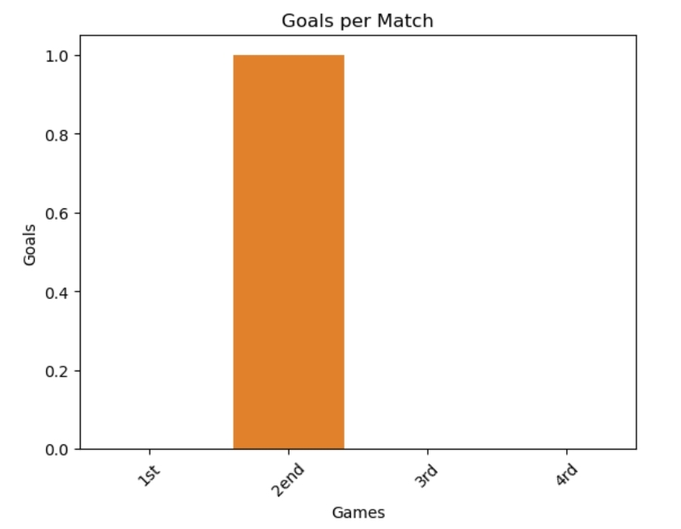
From the first graph we notice that the player scored one goal in four previous matches in the second match.

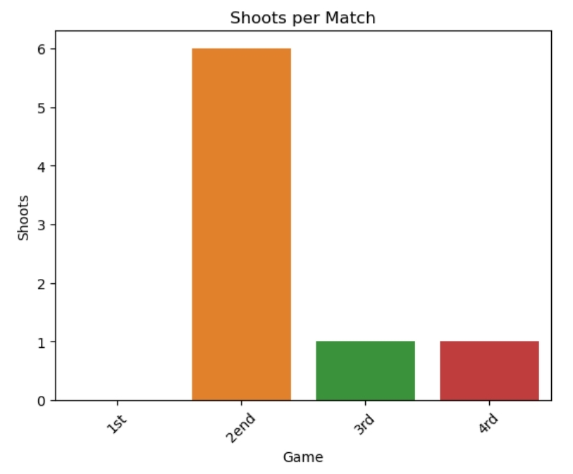
We notice in the second graph that the player made 7 passes in the last four matches:
6 passes in the second match,
and one pass in each of the third and fourth matches, so we record a decline in the last two matches.

4- Feature Engineering

* Selected important features such as number of shots, minutes played, recent match performance, etc.

* Created the final dataset for model training and testing.

* Scaled or normalized features if required.

5- Model Building

* Chose a machine learning model (e.g., Linear Regression).

* Trained the model using the training dataset.

* Tuned model parameters for better accuracy (if applicable).

6- Model Evaluation

* Evaluated the model using metrics such as Mean Squared Error (MSE), Root Mean Squared Error (RMSE), and R虏 Score.

* Compared predicted goals with actual goals in the test set.

7- Prediction

* Used the trained model to predict the number of goals Rahimi may score in upcoming matches.

* Analyzed the predictions and visualized the results.

